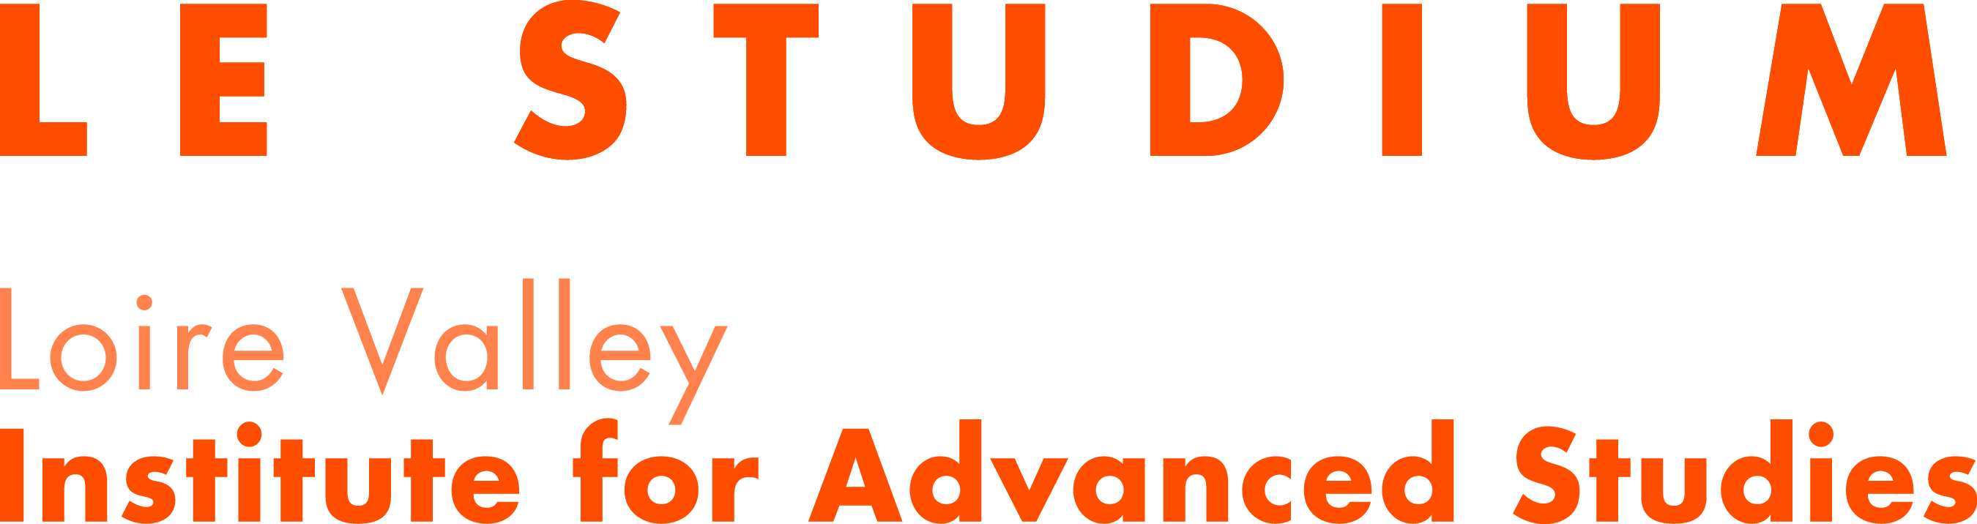

SMART LOIRE VALLEY (SLV) Programme

LE STUDIUM Visiting Researcher award
Part B – Scientific proposal

Applicant:

Host Laboratory:

Host Scientist:

Title of the project:

Important: This cover page is not included in the 10-page limit. Counting starts on Page 2.
Section 1 : Scientific Project

- State of the Art
Describe the State of the Art in the field related to the project

- Aims
Describe the specific aims of the project, including a clear statement of the hypothesis to be tested

- Significance
Describe the importance of the problem to be researched, the planned outcome of the research, and the potential significance of the research.

- Research plan
Describe the methods and techniques to be used and research plan, including as appropriate:
- Description of the experiment design;
- Techniques to be used;
- Methods of statistical analysis;
- Strengths and challenges of the study design

Section 2: Impact of the proposed research

- Innovation
Describe the innovative aspects in the proposal specify the contribution of the research project to the development of knowledge in the scientific field.

- Interdisciplinarity
If relevant, show how the proposed research project connects various scientific disciplines.
If relevant, describe how interdisciplinarity is a key factor of the application.

- Collaborations between laboratories or partnerships with socio-economic sectors
If relevant, present the collaborations that are proposed for the project. These partnerships can be other academic laboratories as well as with private or public companies or socio-economic stakeholders.

- Intellectual property / industrial applications
If relevant, describe the applications related to the research project regarding industry, economy and/or society. If intellectual property strategy with your host scientist laboratory is already defined, the applicant is invited to present it.

- Exploitation and dissemination of results
Describe how the new knowledge generated by the proposed research will be disseminated and exploited, and what the potential impact is expected to be. Discuss the strategy for targeting peers and key stakeholders (such as the scientific community, industry, professional organisations, policy makers, etc.).

Section 3 : Career and track record

- Track record of the applicant
Highlight the career achievements of the applicant and awards including a list of peer reviewed publications in the last five years. Identify up to five publications from this list relevant to this proposal EXCLUDING submitted papers. Book chapters and books should be listed separately.

- Career development
Explain the relevance of the SMART LOIRE VALLEY LE STUDIUM Visiting Researcher award for the career development of the applicant.

- Developing long lasting research links
Indicate if there is a strategy for long lasting research collaboration between the applicant and the host laboratory or host scientist.

- Investment of the home institution
If relevant, explain how the home institution is engaged is the proposed Fellowship. If the home institution considers a reciprocity, describe the considered scheme.

- Relevance of the host laboratory choice
Explain why the applicant has chosen the host laboratory for his/her research project.

- Transfer of knowledge between the fellow and the host laboratory
Outline how a two-way transfer of knowledge will occur between the applicant and the host laboratory:
- Explain what new knowledge the applicant will gain during the Visiting Researcher residency at the hosting organisation and how it will be acquired
- Outline the previously acquired knowledge and skills that the researcher will transfer to the host organisation

