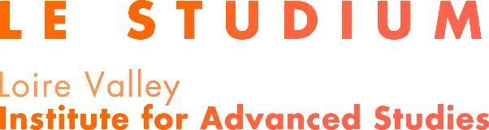

SMART LOIRE VALLEY (SLV) Programme

LE STUDIUM VISITING ARTIST Award
Call for Projects 2023
Part B – Scientific proposal

Applicant:

Host Laboratory:

Host Scientist:

Title of the project:

Important: This cover page is not included in the 8-page limit.
Section 1 : Artistic Project
- Aims and significance
Describe the specific aims and planned outcome of the project and the potential significance of the proposed artistic project.

- Methodology
Describe the methods and techniques to be used, including as appropriate:
- Description of the project design;
- Techniques to be used;
- Strengths and challenges of the project design

Section 2: Impact of the proposed project
- Innovation
Describe the innovative aspects in the proposal specify the contribution of the project to the development of knowledge in the scientific field.

- Interdisciplinary dimension
If relevant, show how the proposed project connects various scientific disciplines.
If relevant, describe how interdisciplinarity is a key factor of the application.

- Links between art and science
Describe how science is a key element of the project and how the artistic project will feed the reflection on the relationship of art and sciences practices and generate cross-fertilisation between art and science.

- Collaborations between artists and laboratories or partnerships with socio-economic sectors
If relevant, present the collaborations that are proposed for the project. These partnerships can be with other academic laboratories as well as with private or public companies or socio-economic stakeholders.

- Exploitation and dissemination of results
If relevant, describe how the new knowledge generated by the proposed project will be disseminated and exploited, and the potential impacts. Discuss the strategy for targeting peers and key stakeholders (such as the scientific community, artists, professional organisations, policy makers, etc.).

Section 3: Career and track record
- Track record of the applicant
Highlight the career achievements of the applicant.

- Career development
Explain the relevance of the SMART LOIRE VALLEY LE STUDIUM Visiting Artist award for the career development of the applicant.
- Developing long lasting research links
Indicate if there is a strategy for long lasting collaboration between the applicant and the host laboratory or host scientist.

- Relevance of the host laboratory choice
Explain why the applicant has chosen the host laboratory for his/her research project.

- Transfer of knowledge between the fellow and the host laboratory
Outline how a two-way transfer of knowledge will occur between the applicant and the host laboratory:
- Explain what new knowledge the applicant will gain during the Visiting Artist residency at the hosting organisation and how it will be acquired
- Outline the previously acquired knowledge and skills that the artist will transfer to the host organisation

